Access Airhead at Home
- Open up your internet browser. (Edge/Chrome/Safari)
- Go to website: http://airhead.io/ or Google Airhead and click the top link.
- On the main page click the sign in button on the top right.
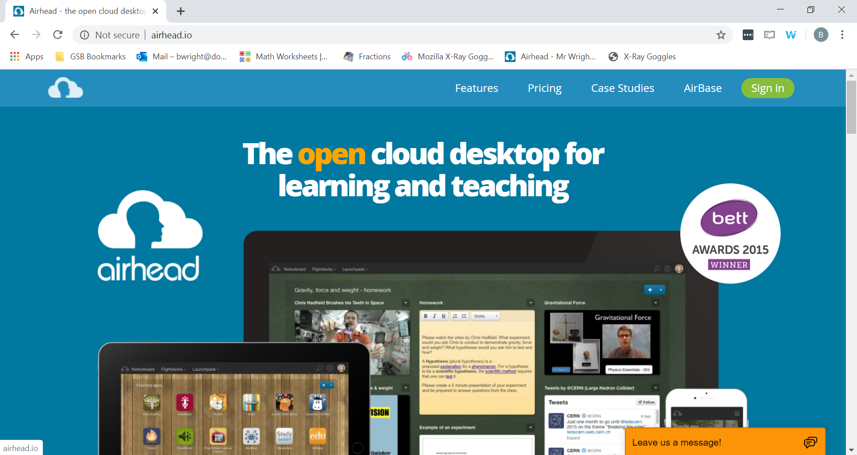

- On the next page type in: Dogsthorpe Primary Academy and click the pop up.
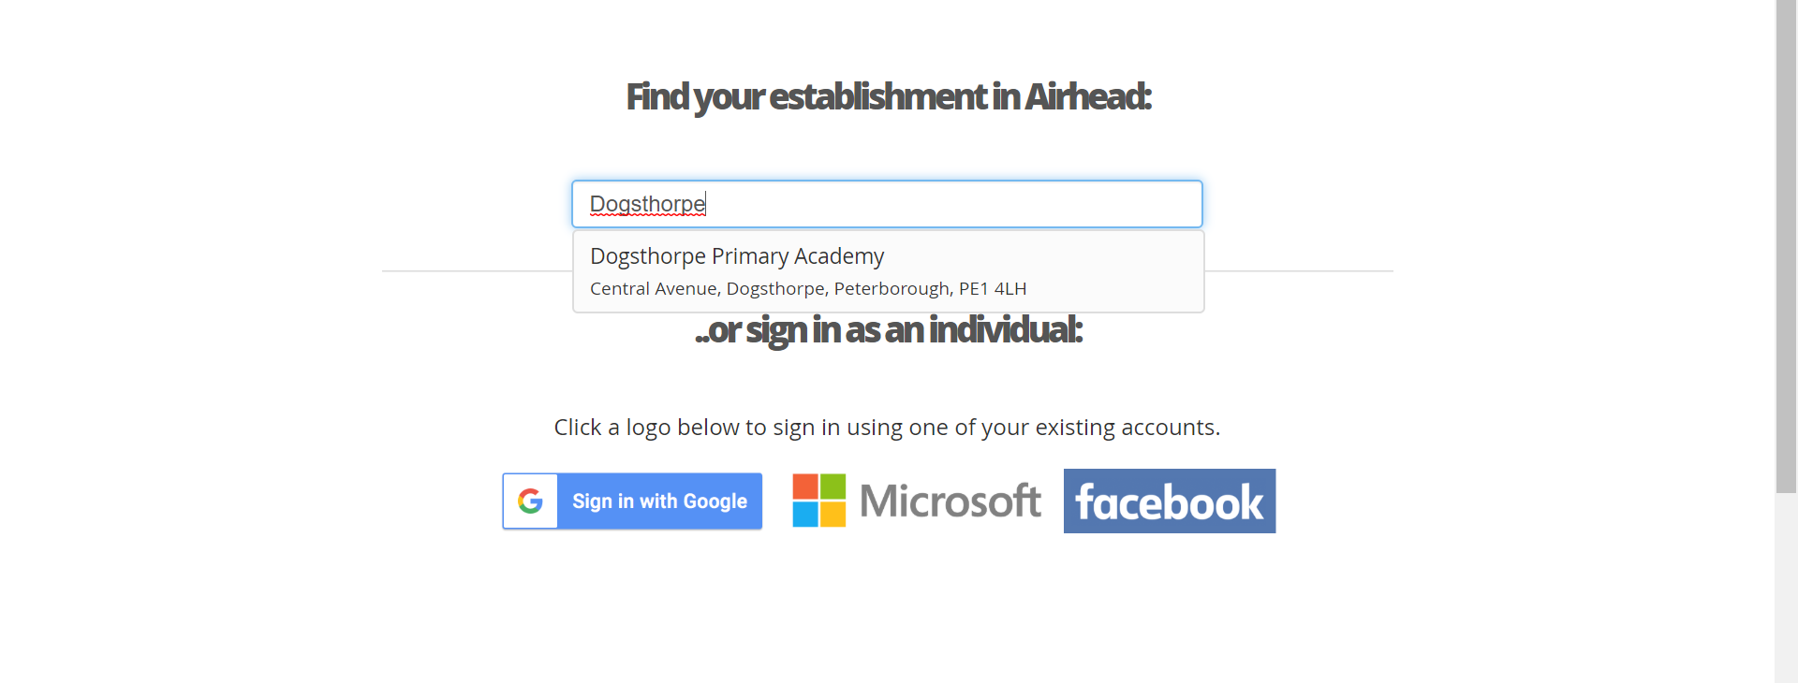

- On the sign in page, log in using your Dogsthorpe Academy email and password.
- The page you end up on should look something like this:
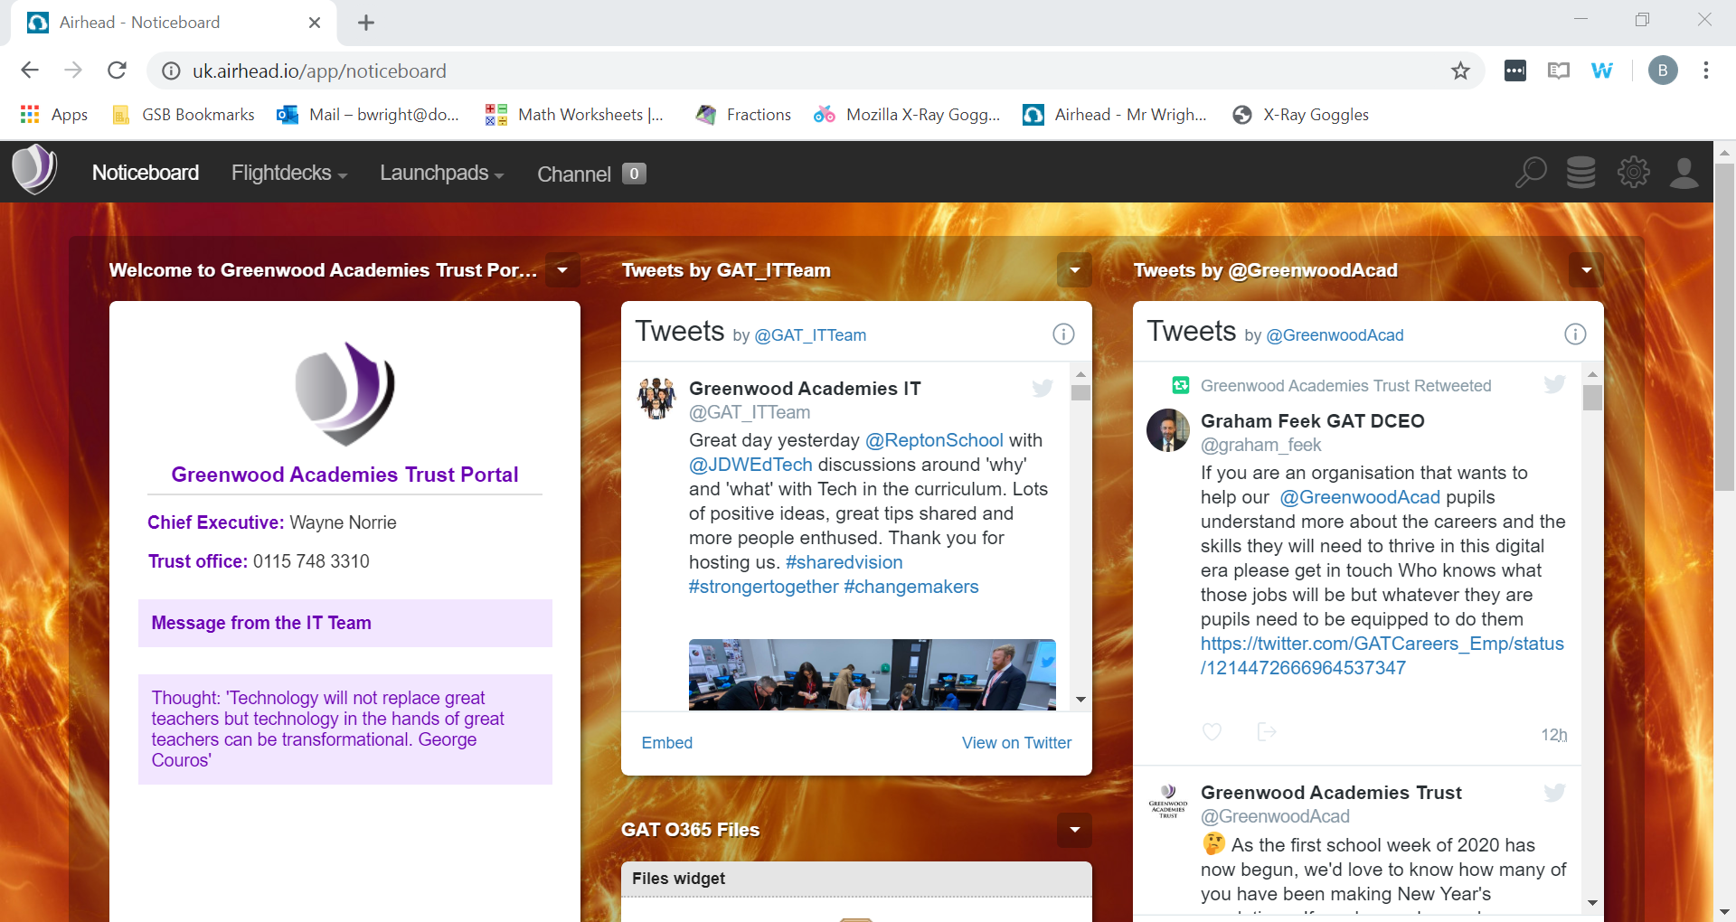

- Use this to access your Launchpad from the top menus.

