Year 6
Spring Two
Domains of Knowledge | Measurement, Perimeter, Area and Volume, Ratio
Key Concepts: | Measurement  - solve problems involving the calculation and conversion of units of measure, using decimal notation up to three decimal places where appropriate  - use, read, write and convert between standard units, converting measurements of length, mass, volume and time from a smaller unit of measure to a larger unit, and vice versa, using decimal notation to up to three decimal places  - convert between miles and kilometres  Perimeter, area and volume  - recognise that shapes with the same areas can have different perimeters and vice versa  - recognise when it is possible to use formulae for area and volume of shapes  - calculate the area of parallelograms and triangles calculate, estimate and compare volume of cubes and cuboids using standard units, including cubic centimetres (cm3 ) and cubic metres (m3 ), and extending to other units [for example, mm3 and km3 ].  Ratio  - solve problems involving the relative sizes of two quantities where missing values can be found by using integer multiplication and division facts  - solve problems involving the calculation of percentages [for example, of measures, and such as 15% of 360] and the use of percentages for comparison  - solve problems involving similar shapes where the scale factor is known or can be found  - solve problems involving unequal sharing and grouping using knowledge of fractions and multiples.
Cross Curricular | (1) interpret and construct pie charts and line graphs and use these to solve problems - Science - beak experiment/Computing - spreadsheets
SMSC Links | Spiritual:  Moral:  Social: explore mathematics in the real world, for example, money, shopping, cooking, travel  Cultural:
Knowledge Broken Down:  Coverage of National Curriculum Objectives | Measurement  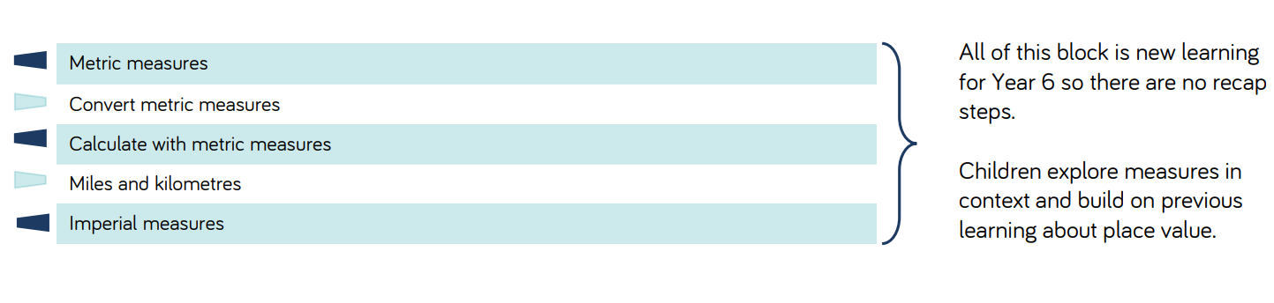  Perimeter, area and volume  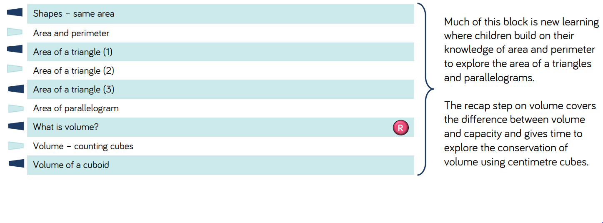  Ratio  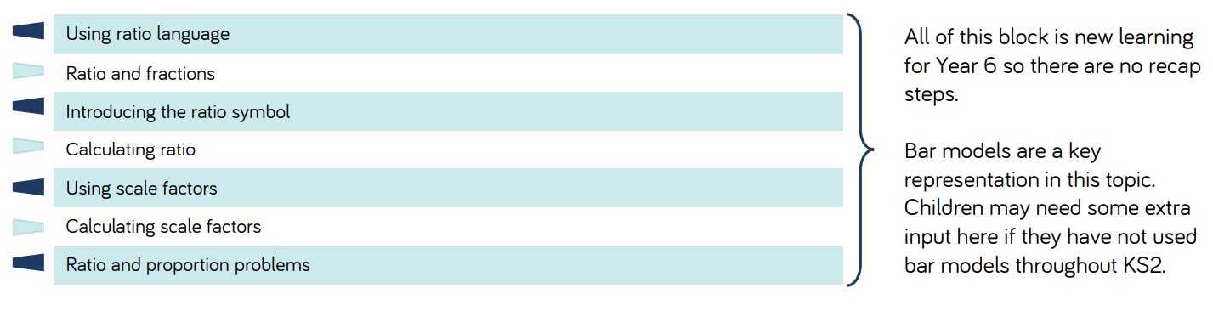
Assessment: | https://assets.whiterosemaths.com/resources-2022/year-6/spring-block-4-converting-units/wrm-y6-spring-b4-converting-measures-assessment.pdf  https://assets.whiterosemaths.com/resources-2022/year-6/spring-block-5-area-perimeter-volume/wrm-y6-spring-b5-perimeter-area-volume-assessment.pdf  https://assets.whiterosemaths.com/resources-2022/year-6/spring-block-6-ratio/wrm-y6-spring-b6-ratio-assessment.pdf

