Year 5
Autumn Two
Domains of Knowledge | Multiplication and division  Measurement: Perimeter and Area
Key Concepts: | Multiplication and division  Pupils should be taught to: ♣ identify multiples and factors, including finding all factor pairs of a number, and common factors of two numbers ♣ know and use the vocabulary of prime numbers, prime factors and composite (nonprime) numbers ♣ establish whether a number up to 100 is prime and recall prime numbers up to 19 ♣ multiply and divide whole numbers and those involving decimals by 10, 100 and 1000♣ recognise and use square numbers and cube numbers, and the notation for squared ( 2 ) and cubed (3 ) ♣ solve problems involving multiplication and division including using their knowledge of factors and multiples, squares and cubes  Perimeter and Area:  measure and calculate the perimeter of composite rectilinear shapes in centimetres and metres ♣ calculate and compare the area of rectangles (including squares), and including using standard units, square centimetres (cm2 ) and square metres (m2 ) and estimate the area of irregular shapes  convert between different units of metric measure (for example, kilometre and metre; centimetre and metre; centimetre and millimetre; gram and kilogram; litre and millilitre)
Knowledge Broken Down:  Coverage of National Curriculum Objectives | Multiplication and division:  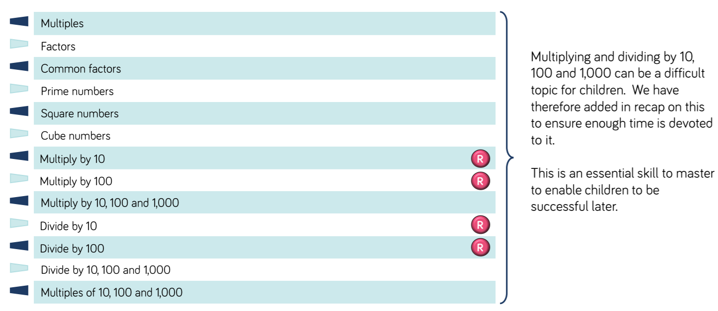  Perimeter and area:  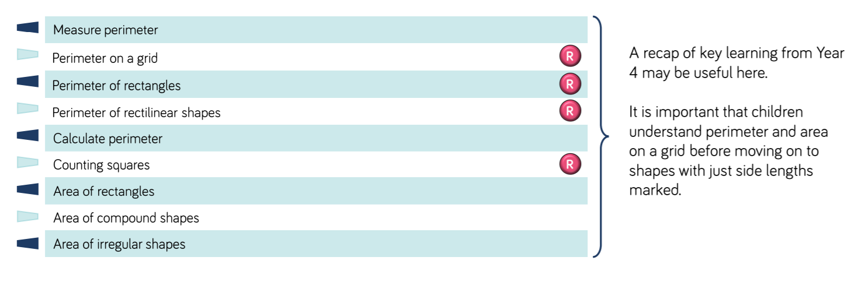
Assessment: | End of block assessment on WR:  https://resources.whiterosemaths.com/resources/year-5/autumn-block-4-multiplication-division/  https://resources.whiterosemaths.com/resources/year-5/autumn-block-5-perimeter-area/  Testbase assessment reasoning multiplication:  https://5bcaf061.exampro.net/

