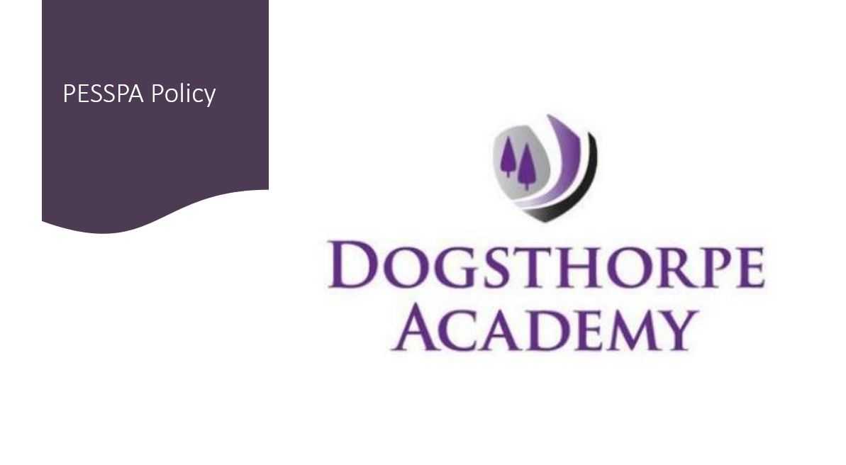
PESSPA Policy

Aims of the Physical Education curriculum at Dogsthorpe Academy
Intent
In line with our Whole-School Curriculum Intentions, and the Academy Improvement Plan (AIP), our PE Curriculum Journey aims to provide all pupils with a stimulating and inclusive educational environment in which:

- Spiritual, moral, cultural, mental, and physical development is promoted.

- Our pupils are prepared for the opportunities, responsibilities, and experiences of later life.

- Pupils study a full curriculum which is coherently planned and sequenced toward building cumulatively sufficient knowledge and skills.

- They learn to behave consistently well and develop positive attitudes and commitment toward their education.

- They have access to a rich set of experiences.

At Dogsthorpe Academy, our key aim is to inspire EVERY child to be passionate about Physical Education and Sport. At school we believe that Physical Education and sport is for everyone! PE is the heart of our academy, and we aim to give all pupils a love for PE, Sport, physical activity, and a healthy lifestyle that continues throughout their lives.
Our teachers use music within PE where appropriate to support our pupils with regards to their enthusiasm and engagement. Music also helps to personalise learning so that it better meets the needs of our diverse learners.

Implementation
Our PE lessons are devised from the Primary PE Planning online Platform. They allow for a consistent delivery and structure across the school. The planning has been developed so that progression is built into the scheme (an exciting learning journey from year 3 through to year 6). This ensures our children are increasingly challenged, inspired and motivated in ALL PE lessons. We believe that mastery is paramount allowing ALL children to feel confident and motor competent when learning key skills. The curriculum provides a foundation from year 3- 6 for an ongoing development of Physical Literacy. Our children receive an inclusive, broad and balanced programme of PE. The curriculum is mapped to ensure that children participate in a wide range of activities.
Our planning is structured through the short, medium and long terms:
Short term lesson plans provide children with the opportunity to develop their skills, develop/build on knowledge & understanding while challenging all abilities. We strongly believe motor competence is key. Children are given clear learning goals and expectations. The lessons allow for feedback, self/peer assessment. The children are also able to develop cognitive skills such as decision making and analysis of performance. Many lessons also have accompanying videos which model powerful demonstrations and through these the children develop a picture of what success looks like and can focus on it.
Medium term planning provides an overview of each unit - it incorporates PE assessment criteria, physical, thinking, social and emotional key skills, cross curricular links and aspects of health and safety. With every unit of work, we have the PPP progression of key skills documents and knowledge organisers. The knowledge organisers provide an overview of prior learning and highlight key terminology, rules and skills. Incorporated within each unit is the second pillar of progression: Rules strategies and tactics that can be through competition, personal bests and teamwork.
Long term planning is created through a curriculum map, this is devised through collaboration with colleagues and children. We also ensure pupil voice- (through Microsoft Forms and individual feedback) is valued. We also link with topic areas (where appropriate), creating strong cross curricular links. Connective planning also incorporates seasonal, local, national and global events including, for example, SSP competitions, Wimbledon, World Cups, amongst many others.

National Curriculum Physical Education Areas of Experience & Development | Our PE Curriculum Journey: Impact  Overview of the end of year age related expectations for National Curriculum PE.
 | Year 3 | Year 4 | Year 5 | Year 6
PHSYICAL | Children copy, repeat, explore, and remember their FMS with increased control. | Children develop a broader range of skills and begin to select and apply them more appropriately with control and coordination. | Children select and use their skills for use in different ways and in different contexts with good control and coordination. | Children link their skills to make actions, sequences and movements. They apply and perform them accurately with precision, control and physical fluency.
PERSONAL | Children engage and collaborate in partner work and small group activity and start to display some simple effective communication and cooperation skills. They follow and understand simple rules for competitive physical activities against others. They are keen to do well. | Children display more developed communication and collaboration skills in partner and group work. They praise others and offer support for teammates. During competitive activity they are able to cope with winning and losing. They want to improve their own performance. | Children display a positive attitude towards co-operative and competitive physical activity. They work effectively as part of a team listening respectfully to the ideas of others and sharing their own. They understand the importance of fair play in competition. They persevere in challenging themselves to improve their own performance. | Children enjoy communicating, collaborating and competing with each other. They consistently work well in team challenges displaying good communication skills. They engage fully in individual and team competitive activities. They always respect rules and display a good sense of fair play. They display resilience and challenge themselves consistently to improve their own performance.
COGNITIVE | Children describe in more detail how their work is different from others’ work and start to use this understanding to improve their own performance. They begin to show an increasing understanding of simple tactics and some basic compositional ideas | Children see and describe in some detail how their work is similar to and different to others’ work and use this understanding to improve their own and others’ performance. Tactical and compositional understanding is improving. | Children observe others and compare and comment on aspects including the skills, techniques, tactics, ideas and composition used. They are now starting to use their findings on a consistent basis to refine their own performance in some physical activities and sports. | Children evaluate and recognise correctly and with consistency, their own and others’ success. They regularly compare & provide feedback on the skills, tactics, techniques, ideas and composition, used in their own & others’ work and use this understanding consistently to make improvements across a range of physical activities.
HEALTH | Children can describe how their bodies feel if they are physically active for sustained periods of time and are aware that their health will benefit. They can give reasons why it is important to warm up before physical activity. | Children know what different intensities of physical activity feel like. They can give some reasons why their health will benefit if they are physically active for sustained periods of time. They show that they can warm-up safely. | Children display a good understanding of the health benefits of engaging regularly in vigorous physical activity for sustained periods of time in and out of school. The plan and demonstrate that they can take their own warm-up and cool-down safely. | Children explain in detail how physical activity and sport contributes to a healthy lifestyle. They engage in a range of physical activity and sport contributes to a healthy lifestyle. They engage in a range of physical activities and sports and can describe some of the different health benefits for each. They consistently warm-up and cool-down safely in ways that suit the activity.

Impact
PE is an essential part of the curriculum and through our PE lessons children develop their physical literacy and key skills giving them the tools to become physically confident and motor competent. Our High-Quality PE curriculum focuses on the whole child, developing their physical, social and thinking skills. Our PE is provided in a safe and supportive environment and is vital and unique in its contribution to a child’s physical and emotional development and health and wellbeing.

We provide opportunities for the children to compete against themselves and others during PE lessons, building character and developing our academy key values including justice (fair play), respect, courage, compassion, and wisdom. As well as communication, collaboration, commitment, leadership, and teamwork.
Our school aims are linked to those in line with the PE national curriculum, which are to ensure that all children:
- Develop competence in a broad range of physical activities.
- Are physically active for sustained periods of time.
- Engage in competitive sports and activities.
- Understand how to improve in different physical activities and sports and know how to evaluate and recognise their own success.
- Lead healthy, active lives.
The ‘Three pillars of progression’ are embedded throughout our curriculum:
These include:
- Motor competence – knowledge of the range of movements that become increasingly sport- and physical activity-specific.
- Rules, strategies and tactics – knowledge of the conventions of participation in different sports and physical activities.
- Healthy participation – knowledge of safe and effective participation.
Teaching and Learning-Curriculum Implementation
Key stage 2
Children should continue to apply and develop a broader range of skills from KS1 lessons; learning how to use them in different ways and to link them to make actions and sequences of movement. They should enjoy communicating, collaborating and competing with each other. They should develop an understanding of how to improve in different physical activities and sports and learn how to evaluate and recognise their own success.
Children are taught to:
- Use running, jumping, throwing and catching in isolation and in combination.
- play competitive games, modified where appropriate [for example, badminton,
- basketball, cricket, football, hockey, netball, rounders and tennis], and apply basic
principles suitable for attacking and defending.
- Develop flexibility, strength, technique, control and balance [for example, through
athletics and gymnastics].
- Perform dances using a range of movement patterns.
- Take part in outdoor and adventurous activity challenges both individually and within a
team.
- Compare their performances with previous ones and demonstrate improvement to
achieve their personal best.
Enrichment and Provision in PE
We also offer and provide the following in order to enrich and enhance the provision of PE at Dogsthorpe Academy:
- 1:1 support in lessons/TA support (where appropriate).
- SEND support: We use primary planning SEND PE support resources; SENsory skills, PE social stories, SEND Task management, Sensory circuits.
- Clubs: afterschool and lunchtime clubs (OPAL) happen every day.
- Competitions attended: YDP tournaments and festivals, GAT competitions and local events.
- Community links: POSH football club, ProKick Challenge
- Events: Sports Day and OAA activities and trips
- Active Daily Minutes: BMX bikes, active playground, daily mile.
Assessment and Recording
Our assessment is embedded into every lesson, this is facilitated by our Progress-o-meters (Traffic Light System) which allow for pupils to assess their own and others' progress in the lesson. These assessments help the pupils focus on what they can do and how they can improve.
The Progress-o-meters (Traffic Light System) also enable teachers to assess the pupils' progress in each lesson. Pupils can be recorded as the following:
- Working towards (Red)
- At expected (Amber)
- Above expected (Green)

The above are also linked to the ‘steps to success’ developed for a Teaching and Learning scaffold, incorporated within every lesson framework.
They also incorporate the National Curriculum attainment targets for each year. In short, the Progress-o-meter (Traffic Light System) creates an individual pupil profile of attainment.
Collation of Data/Progress and Attainment
We monitor progress and attainment using a combined approach: through the PPP tracker tool and Insights Tracker. Teachers refer to the statements on PPP tracker and use these to inform their judgements and termly assessments. External providers also provide their own assessments on a termly basis.
Through the PPP PE tracker tool, we also assess children’s swimming attainment. We examine the following criteria:
- Swim competently, confidently and proficiently over a distance of at least 25 metres.
- Use a range of strokes effectively [for example, front crawl, backstroke and breaststroke].
- Perform safe self-rescue in different water-based situations.
Monitoring and Evaluation

The Sport Lead is responsible for the overall monitoring of the quality of PE and Physical Activity provision at Dogsthorpe Academy. PE in the curriculum is monitored across the year in order to provide an accurate perspective on how it is being delivered and suggestions on how it may possibly be further improved further.

Physical Education at Dogsthorpe Academy is monitored and evaluated through:

• Lesson observations/Learning walks
• Monitoring of equipment
• Pupils Assessment data
• Feedback from staff
• Pupil voice
• Pupil records of participation, focusing on different groups activity
• Pupil attendance and achievement in sporting competitions
• Attendance at after school sports clubs

Our external providers are used to deliver physical activity across the school. Coaches are regularly observed by the owner of the external provider as well as the Sport Lead, to ensure that high quality lessons are delivered and assessed consistently and where appropriate that schemes of learning/on-line platform resources are being used in order to ensure consistency of approach and delivery.

Equal Opportunities

At Dogsthorpe Academy, we are committed to promoting equal opportunities irrespective of socio- economic background, gender, disability, and ethnicity in all areas of the curriculum. We believe that our pupils should have equal access to and participation in all that is offered within Physical Education lessons and beyond. Teaching staff plan their lessons and make necessary adaptations and/or differentiation to ensure appropriate challenge and accessibility for all learners.

Inclusion

At Dogsthorpe Academy, we are committed to ensuring that all pupils participate in PE and physical activity irrespective of any special educational need(s) or physical disability they may have. We believe that pupils should have equal access to and participation in a range of physical education activities in order to reach their own potential. We also use the SEND resources provided by Primary PE planning in order to support our PE provision. We believe that Physical Education and sport is for everyone!

EAL

Support is provided to our EAL learners in our PE lessons. Due to the nature of PE, where access cannot be gained through verbal understanding, children will be encouraged to observe or copy and repeat either their peers or the Class Teacher. Fortunately, through our on-line platform (Primary PE Planning) many lessons are complemented with video tutorials, visual aids and resource cards and these act as a learning stimulus for ALL including EAL pupils. They are provided with the tools that will allow them to gain an insight as to what is required to succeed in the lesson.

Training and support for staff

At Dogsthorpe Academy, we strive to ensure that ALL members of staff delivering PE are able to access high quality professional development when required. This can relate to ongoing delivery of activities in order to keep them fully up to date on key related issues and ensure they are confident to teach the full breadth of the curriculum. We also consider personal requests for CPD from staff members when required in order to progress them professionally. This training can be accessed through individual and group CPD and educational initiatives provided by the Local Authority and outside agencies. As a staff we are also able to access interactive zoom training/Staff CPD with reference to providing consistent lesson delivery and assessment through our on-line provider Primary PE Planning.

Health and Safety

Physical Education and participation within it can carry some risk. It is the responsibility of the staff delivering PE to ensure that the risk is minimised with the correct implementation of safe practice protocol.

As a school we undertake detailed risk assessments on every aspect connected with the delivery of PE. These can range from an outside agency risk assessing PE apparatus and equipment, our day to day provision for PE within the curriculum, extra-curricular activities and any possible sporting ventures or trips which will take place off site.

All staff working alongside our pupils in PE are made aware of any disabilities or health problems and are knowledgeable as to individual needs and provision. They are informed of the procedure for reporting or dealing with any issues pertaining to incidents which may arise during PE sessions. Parents and pupils are also frequently reminded and actively encouraged to ensure that all personal medical necessities required for participation are at hand during activity, for example asthma inhalers.

Experienced staff will demonstrate to all new staff members how to lift, carry and place apparatus safely and how the pupils should move apparatus.
Pupils are made fully aware of safety issues during set up and participation in PE sessions.

Correct clothing and footwear must be worn. All teaching staff and pupils should wear clothing suitable for delivering or participating in PE. Pupils are to have bare feet (where possible) for indoor activities including dance, gymnastics, mini-muay thai and yoga. Pupils are not permitted to wear watches and jewellery; earrings should be removed for the PE lesson. They must be covered by the parent/child if they cannot be removed. Long hair must also be tied back or up.

Pupils should also have available a water bottle from which they can hydrate themselves during physical activity. The importance of hydration should be encouraged by all as an important aspect of a healthy balanced diet and active lifestyle.

If a pupil is excused from PE for medical reasons the pupil will still be fully involved in PE (where appropriate), participating as a ‘mini-coach’ within the lesson. If they are well enough to - we will ask them to get changed into PE kit.

