Year 6
Autumn Two
Domains of Knowledge | Fractions  Geometry: position and direction
Key Concepts: | Fractions:  Pupils should be taught to: ♣ use common factors to simplify fractions; use common multiples to express fractions in the same denomination ♣ compare and order fractions, including fractions > 1 ♣ add and subtract fractions with different denominators and mixed numbers, using the concept of equivalent fractions ♣ multiply simple pairs of proper fractions, writing the answer in its simplest form [for example, 4 1 × 2 1 = 8 1 ] ♣ divide proper fractions by whole numbers [for example, 3 1 ÷ 2 = 6 1 ] ♣ associate a fraction with division and calculate decimal fraction equivalents [for example, 0.375] for a simple fraction [for example, 8 3 ] ♣ identify the value of each digit in numbers given to three decimal places and multiply and divide numbers by 10, 100 and 1000 giving answers up to three decimal places Mathematics – key stages 1 and 2 41 Statutory requirements ♣ multiply one-digit numbers with up to two decimal places by whole numbers ♣ use written division methods in cases where the answer has up to two decimal places ♣ solve problems which require answers to be rounded to specified degrees of accuracy ♣ recall and use equivalences between simple fractions, decimals and percentages, including in different contexts.  Position and direction:  Pupils should be taught to: ♣ describe positions on the full coordinate grid (all four quadrants) ♣ draw and translate simple shapes on the coordinate plane, and reflect them in the axes
Knowledge Broken Down:  Coverage of National Curriculum Objectives | Fractions:  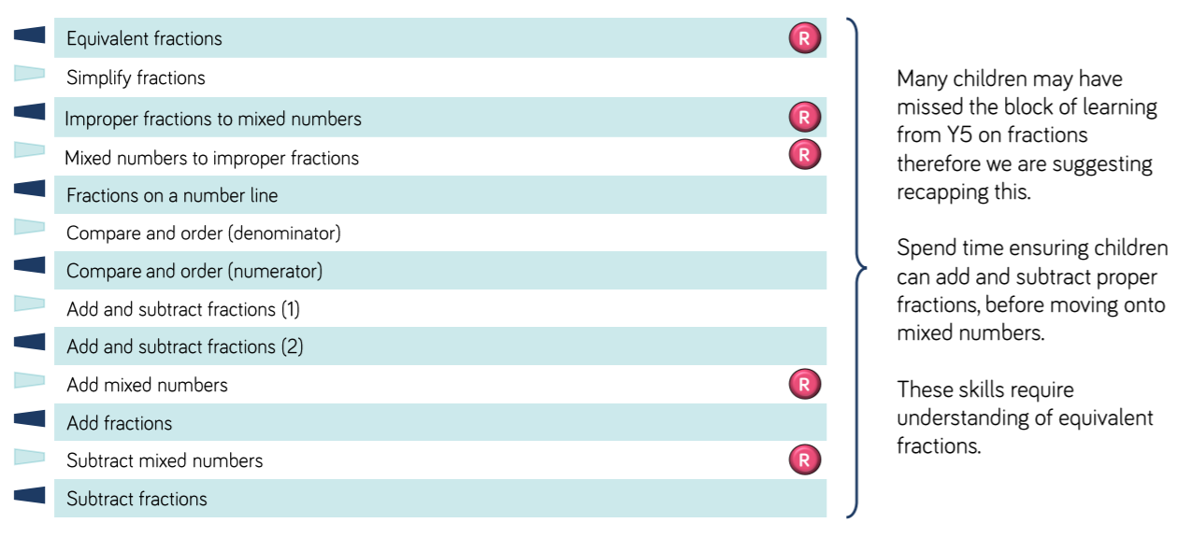  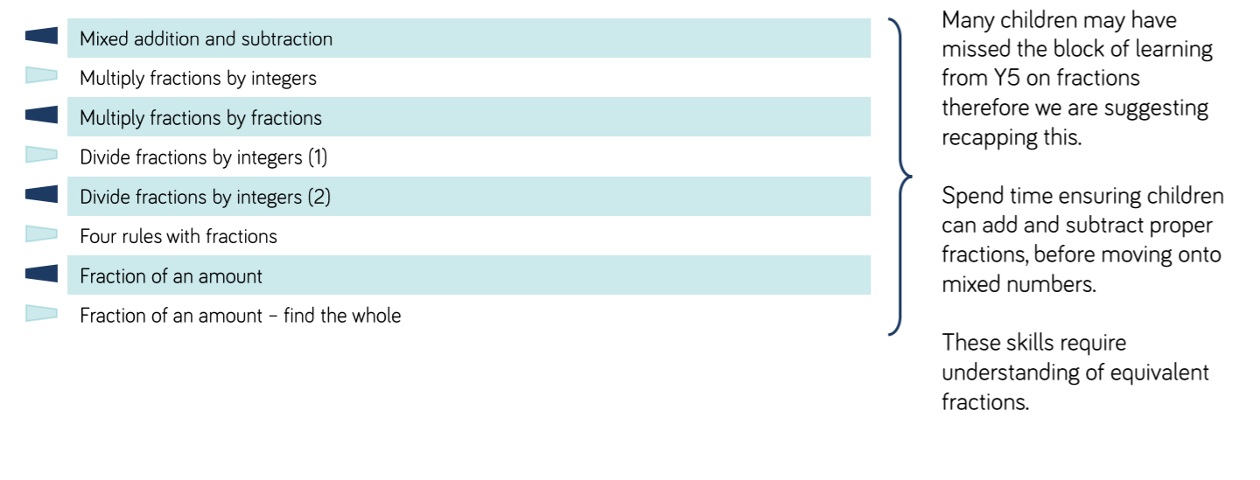  Perimeter and area:
Assessment: | End of block assessment on WR:  Fractions: https://whiterosemaths.com/wp-content/uploads/2020/08/Year-6-Autumn-block-3-Fractions.pdf  Position and direction: https://resources.whiterosemaths.com/resources/year-6/autumn-block-4-position-direction/  Testbase Year 6 questions  Build a mathematician assessments fractions:  https://old.kangaroomaths.co.uk/free_resources/assessment/BAM/6M6_BAM.pdf  https://old.kangaroomaths.co.uk/free_resources/assessment/BAM/6M7_BAM.pdf  https://old.kangaroomaths.co.uk/free_resources/assessment/BAM/6M8_BAM.pdf  Build a mathematician position and direction:  https://old.kangaroomaths.co.uk/free_resources/assessment/BAM/6M12_BAM.pdf

