Year 6
Summer One
Domains of Knowledge | Statistics  Properties of shape
Key Concepts: | Statistics  - interpret and construct pie charts and line graphs and use these to solve problems  - calculate and interpret the mean as an average.  Properties of Shape  - draw 2-D shapes using given dimensions and angles  - recognise, describe and build simple 3-D shapes, including making nets  - compare and classify geometric shapes based on their properties and sizes and find unknown angles in any triangles, quadrilaterals, and regular polygons  - illustrate and name parts of circles, including radius, diameter and circumference and know that the diameter is twice the radius  - recognise angles where they meet at a point, are on a straight line, or are vertically opposite, and find missing angles.
Cross curricular | (1) solve problems involving the calculation and conversion of units of measure,
SMSC Links | Spiritual:  Moral: use probability to help them understand risk and real life economics  Social:  Cultural:
Knowledge Broken Down:  Coverage of National Curriculum Objectives | Statistics  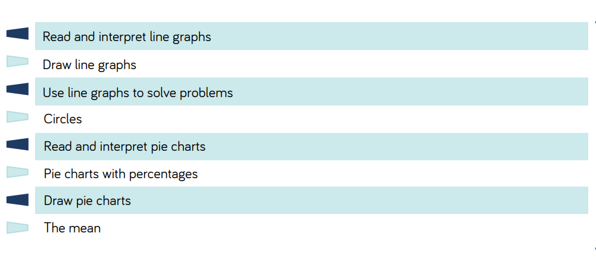  Properties of Shape  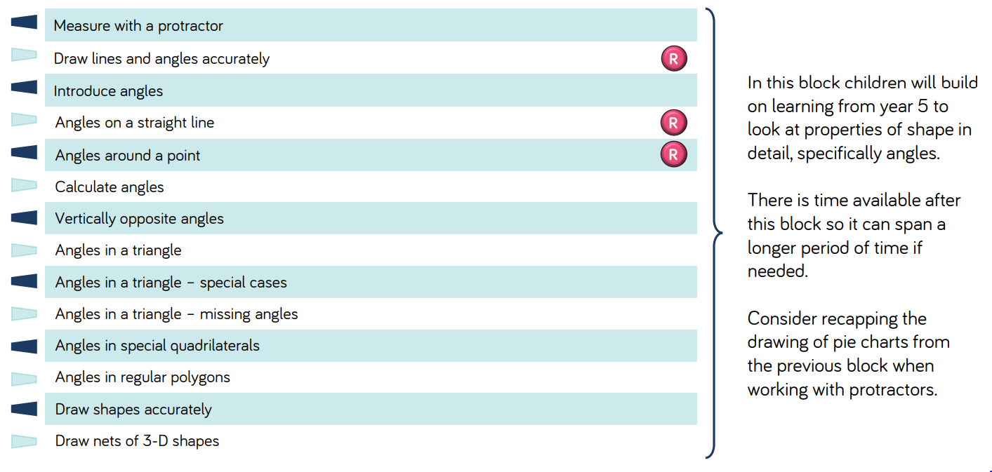
Assessment: | https://assets.whiterosemaths.com/resources-2022/year-6/summer-block-1-statistics/wrm-y6-summer-b2-statistics-assessment.pdf  https://assets.whiterosemaths.com/resources-2022/year-6/summer-block-2-properties-of-shape/wrm-y6-summer-b1-properties-shape-assessment.pdf

