Year 3
Spring One
Domains of Knowledge | Number: Multiplication and Division, Measurement: Money, Statistics
Key Concepts: | Multiplication  - write and calculate mathematical statements for multiplication and division using the multiplication tables that they know, including for two-digit numbers times one-digit numbers, using mental and progressing to formal written methods  - solve problems, including missing number problems, involving multiplication and division, including positive integer scaling problems and correspondence problems in which n objects are connected to m objects  Money  - add and subtract amounts of money to give change, using both £ and p in practical contexts  Statistics  - interpret and present data using bar charts, pictograms and tables  - solve one-step and two-step questions [for example, ‘How many more?’ and ‘How many fewer?’] using information presented in scaled bar charts and pictograms and tables.
Cross curricular (must be evidenced in books) | Rocks and Soils - linked to topic Math - graphing water permeability of rocks
SMSC Links | Spiritual:  Moral:  Social: use maths to solve problems in real life including money problems  Cultural:
Knowledge Broken Down:  Coverage of National Curriculum Objectives | Multiplication and division  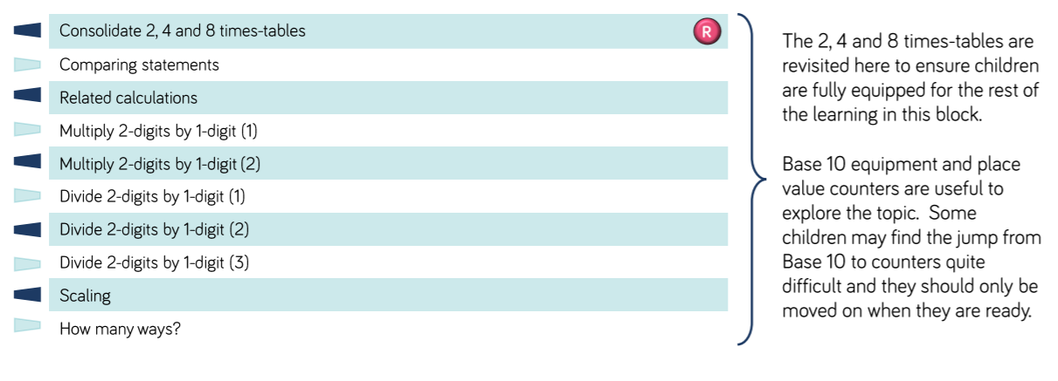  Measurement: money  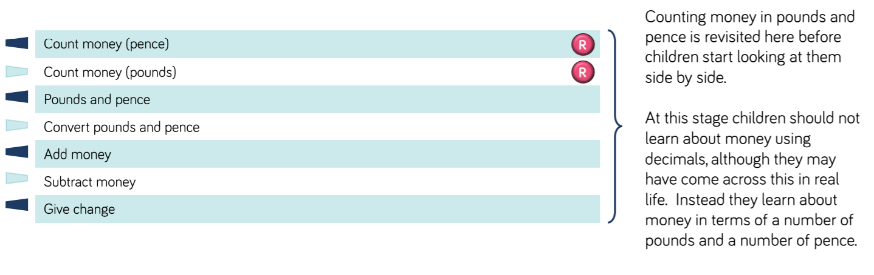  Statistics
Assessment: | Testbase end of topic units: https://resources.doublestruck.eu/resources/res-k2-reas.php?otheme=TB  WR end of unit assessments

